PARTICIPANT DAYS INFORMATION

INTRODUCTION 2
PARTICIPANT REGISTRATION + MAKING THE SCHEDULE 2
Registration 2
Schedule 2
Excel 3
PAYMENT 4
PROMOTION 4
Material 4
Online 5
Internals 5
EXPERIMENTS FROM RESEARCHERS 5
REIMBURSEMENT 6
Procedure. 6
EVALUATIONS 7
2018 7
2017 8
Example invitation mail: 10
2016 13

INTRODUCTION
This document outlines the most salient points for the participant days, it has been written with the idea in mind of solely being practical guide; so only pragmatic information is presented. Most additional documents can be found on:
http://coglabwiki.psy.vu.nl/index.php/Main_Page
When promoting the event make clear that it is a first come first serve system, and that if you are not able to do a certain of experiment, or have restricted availability it will be harder to schedule all the desired hours. Also indicate that start and end times can vary between 9:30 and 13:30 for morning and 13:30 to 17:30 for the evening sessions.

PARTICIPANT REGISTRATION + MAKING THE SCHEDULE

Registration
In order to make a good planning some pp info has to be collected, this should be automated.
Use either google docs, or even better Qualtrics. An example survey is available on the cogsci website
[LINK QUALTRICS]
Note that this survey is incomplete and should be beta tested before use, at the moment it is an example.
- A random number should be assigned at the end to every pp that fills out the survey.
- An option for time of day preference should be added
Per day you can invite a maximum of 28 people, 14 in the morning, and 14 in the afternoon.
This is if there are also eeg and eye tracking experiments.
Make sure that as soon as you open the survey you keep a constant eye on how many people register, so that once the limit is reached you can stop promoting the participant days.
Also add the option of “back up participant” each day you should have 1 or 2 people that are able to do every experiment, ideally have no optical corrections and come into the lab a bit later and wait for 30 minutes and can take the place of a potential drop out participant, these participant should be paid 1 hour for the 30 minute waiting time.

Schedule
Use excel, since the schedule will change along the way and there is a need to keep automated track of which studies which pp has completed. Make sure that the information from the qualtrics surveys is able to communicate with the excel sheet: e.g. use the same pp numbers that the survey assigned, split groups by experiment preference, optical / no optical correction ect.
The most important functions of the excel doc are:
-keep track of how many pp are planned in the labs at any one time, in order to avoid overlap
-keep track of how many people have pp in a specific experiment
-keep track of which studies a specific pp has completed
Lab K1F46 lab has 9 cubicles, there are two EEG labs (three if a researcher is able to use passive electrodes), and three eye tracking labs. This means that if there are enough experiments a total of
14 ppl (9+2+3) can be tested per session of three hours, for a whole day this is 28, since pp can only do a maximum of three hours.
If there are two research assistants testing, K1-F71 can also be used, which has 6 cubes. Make sure to not fully book this lab in order to be able to use it as an overflow area in case there are conflicts.

Excel
there is a small example doc here on the cogsci webpage.
[link to excel doc]
This can be improved upon, it is just here to show basic ideas of tracking studies + pparticipants
=ISNUMBER(SEARCH("study_name",schedule_monday!B2:B10))

Excel also has some scheduling template premade, which might be handy to have a look at.

PAYMENT
In 2016 through 2018 the payment was as follows:
10 euros per hour (3 hours max. per day = 30 Euros per day)
Bonus for 2 days = 15 euro
Bonus for 2x2 days (4 days) = 30 euro
Bonus for all 5 days = 50 euro
These bonuses are not cumulative, that is to say you either get a bonus for four days or for 5 days, not both.
Total possible pay, including payment per hour and the bonus would be for five full days, and is 200,-
I would suggest to add also a bonus for three days, leading to a simpler system of
2days: 15
3days:25
4days 35
5days: 50
Make sure to communicate that participants might be in the lab a bit longer or shorter but that for one full day payment is 30 euros, and that only in extreme cases will we add additional pay.

PROMOTION

Material
Flyer and poster templates are available on the Cogsci website; the payment information should be made abundantly clear.
[LINK FLYER + POSTER]
You can print these at the repro in main building for about 60 euro’s for A5 flyers and another 15/20 for color A3 posters.
https://www.vu.nl/nl/over-de-vu/campus/faciliteiten/reprografie/index.aspx
When making promotion material it is essential the payment system is abundantly clear, so make sure that payment per hour, per day and the bonus for multiple days is clear (clearer then on the template provided).
Also note that if the VU logo is on the posters you will need permission to hang the posters on designated areas around VU campus. Permission comes through sending an email to fco servicedesk:
servicedesk.fco@vu.nl
https://vunet.login.vu.nl/services/pages/detail.aspx?cid=tcm%3a164-301093-16

Online
Unfortunately one of the main ways is still via the data stealing giant facebook. There is a cognitive department facebook page. As the research assistant you should have access to this account and able to post on here. A twitter or other accounts are not yet available, these can be created, make sure to create accounts that are transferable to a possible future research assistant.
Use at least the following tags when posting on facebook:
@vuamsterdam
@VUinternationalstudents
@Cognitive Neuropsychology RM
@uilenstede
(try to find exact names when posting, they should pop up automatically)

Internals
Gonneke Willemsen or Sander Los will be able to send email bursts to the first year psychology students, contact them with a prepared message and links to the facebook page and qualtrics survey.

EXPERIMENTS FROM RESEARCHERS
Make sure to have at least 25+ experiments of 1 hour.
Ideally some back up experiments should also be present in case an experiment does not work is too difficult, completed early, etc.
Try to avoid:
-experiments with two parts (on separate days),
-Multiple experiments sequential that require unique participants (since most participants will do all studies that are available,)
-Experiments that need precise counterbalancing.
Researchers tend to come late with detailed information, push them to deliver early so you can test all experiments well in advance.
Send out an email o the “fgb medewerkers CP” maillinglist, example email can be found here Example invitation mail:

REIMBURSEMENT
Receipts can be entered in VUnet for reimbursement, do this for poster/flyer material and for food, drinks + drink cups, coffee pads, etc for participants.

Procedure.
All receipts have to be in PDF format, use (online) PDF converter for other file types.
Vunet:
Sevices
Finances
Claims
Reimbursement vu personnel
At top of page click: “Take action now” and follow the steps

Link:
https://vunet.login.vu.nl/services/pages/categorydetail.aspx?cid=tcm:165-863235-16&category=tcm:165-292210-1024

EVALUATIONS

2018
The theme of this year’s pp days was ‘lack of automation’ and this lead to most problem encountered, make sure to make automation a priority.
The scheduling takes the most time and is the most important. This should be done well in advance and be automated so that it dynamically tracks the participations of individual pp’s, tracks if the lab is available at a given time and keeps tracks of how many and which pp participated in a certain study. The example excel sheet can give you some hints at how to organize this.
One other important note is that pp need to be carefully informed about the payment: make sure that on the poster, in the email and all other material the payment is made abundantly clear. Also make sure that if you see the participants in the lab the first thing you check is if they understood they payment system and if they agree to the terms.
Also make sure to book the labs via the VU /outlook agendas.
Make sure to communicate to participants that they might be in the lab a bit longer or shorter but that for one full day payment is 30 euros, and that only in extreme cases will we add additional pay.
Try to schedule from 9:30 to 13:00 and from 14:00 to 17:30, that gives you 30 minutes of space to play with within the three hour requirement.
The documents above can be edited at will, you can also add a more freeflowing evaluation here at the end of the document, keep in mind to try to make sure that the next pp days will be easier for the next research assistant.

2017
Evaluation PPdays 2017

In this evaluation I will try to describe the process of organizing the PPdays, how I approached it and possible ways to improve this.

To organize the PPdays, I closely followed the directions that were provided on the wiki page (see Organization_PPdays.docx). To start, you have to choose a week for the participant days. To this end, it is a good idea to ask around when everyone is available, on vacation or away at conferences. Try to make sure you choose a week when most PhDs are available. Next, I contacted the staff to inform them of when I was planning to organize the participant days and to take stock of everyone that wanted to participate. In this mail I also asked them for a few details regarding their experiments, i.e., how many experiments they would like to run, an estimation of their running time and the requirements regarding equipment and participants. Additionally, concerning the PhDs, I asked their preferred testing days and testing room. Because you won’t be running their experiments, but you will need to compile a schedule that fits their needs. Make sure to also send a few reminders, because people tend to forget to reply.
Looking back on this whole process, I would like to recommend contacting the staff a bit earlier than I did (I contacted them about 1.5 month in advance), to give them more time to prepare their experiments but also to give yourself a larger window to choose a suitable week. I would like to recommend contacting the staff about 2-3 months in advance.

The next step is inviting the participants. In the past you could contact a lot of possible participants using the EMS newsletter, but unfortunately this is no longer possible due to privacy concerns. Thankfully, there are a few other good options still available. First, you can advertise on Facebook. Try to do this on several pages like the Cognitive Psychology page, the Cognitive Neuropsychology masters page, the VSPVU page, the Bachelor psychology pages etc. Second, you can contact previous participants using Sona-systems. Try to use the contact list of the more recent experiments to reach an audience that is more likely to respond. Furthermore, you can make flyers that you can spread across VU campus and Uilenstede. Make sure to leave also a pile of them in the different labs in the building (also the social psychology lab). Finally, you can notify participants of these testing days leading up this week. If their interested, you can note down their email address and invite them when the time comes.
In my opinion it is best to start inviting the participants about 5 weeks in advance. Make sure to also give them a clear deadline till when they can enroll. People who reply too late can function as reserves and possibly replace last minute cancelations (very useful!). See below for an example invitation mail.

The final step before the actual participant days start is compiling the schedule. This is a real pain and can get pretty complex depending on the experiments and the wishes of the participants. It is very useful to organize all participant information and the different experiments in a clear excel file. For an example, I added a screen (of a small part) of my schedule below.
In hindsight, I hugely underestimated the amount of work it was to compile the schedule. I think it is probably best to plan a few days in to just compile the schedule and try to finish the this a week before the participant days. This way you leave yourself some room to make some last minute changes in schedule.

During the participant days you won’t have much time, so prepare as much as you can before the actual testing starts, e.g., calibrate the screens, start the experiments in the cubicles, hang out schedules etc. Keep in mind thatsome participants will be late and some of them will cancel. Try to be as flexible as possible and make adjustments in the schedule when necessary. Contact thereserves to replace possible cancelations. Replacements for EEG and eye-tracking studies have a higher priority than behavioral studies.
Jozua Murris

Example invitation mail:

On the 21st till the 25th of August we are running approximately 22 different experiments, in which you can participate. There will be behavioral experiments (in which we look at how you respond to certain situations during computer experiments), eye-tracking experiments (in which we are interested in your eye-movements), and EEG experiments (in which we record data form electrodes on your scalp regarding your brain activity).
Each day, you may do up to 3 hours of experiments, and you are able indicate whether you would like to participate in the morning (10:00 to 13:00) or in the afternoon (13:00 to 16:00). Though we do not allow you to do more than 3 hours on one day, you are more than welcome to come 2 or more days in a row!
What do you get?
We pay €10 per hour. Additionally, if you come two days in a row, you can earn a bonus of €15. If you come five days in a row, you can earn a bonus of €50! Therefore, you can earn up to €200 in four days! Besides, we offer coffee, tea and some snacks to keep you going.
What do we expect from you?
If you want to earn money by doing experiments, it is important that you take it seriously and do your best. We expect you to come to the lab well-rested and healthy. You are not allowed to take your bag, coat and/or phone into the experiment. There is space to leave your things at the continuously guarded coat rack.
What do you have to bring?
To be able to pay you, we need your BSN (Civilian Registration Number) and a valid ID card/passport, as well as your bank details and address.
How can you participate?
In order to create a schedule for these 5 testing days, we need to know exactly who can participate when and in what types of experiments.
If you want to participate, please send an e-mail to …, containing the following information, before the 11th of August:
- Your name as in your passport
- Your date of birth
- Your gender
- Your native language
- Whether you have any optical corrections, and which kind (glasses, hard/soft contact lenses)
- Your dexterity (right-/ left-handed or both)
- Whether you have any language disorders (e.g. dyslexia)
- Your availability: morning (10:00 – 13:00) or afternoon (14:00 – 17:00) for each day that you would like to participate
- What kinds of experiments you’d rather not perform (e.g., eye-tracking, EEG or behavioral).
- Any other questions/remarks
Please feel free to invite your friends, relatives, colleagues, roommates, etc. to join as well.
Unfortunately, we are not able to test people who are partially or completely colorblind. Furthermore, participants should be between 18 and 35 years old.
Once you have sent us your information, you will receive your personal participation ID. Before the 19th of August, you will receive the experiment schedule. In the schedule you will find exactly in which experiments you will participate at what times, by looking for your participation ID. This way, the schedule is completely anonymous. In order to ensure a smooth run of events, we ask you to be present at the lab at least 15 minutes before your first experiment begins.
If you would like to participate, please send us an e-mail with your details as mentioned above before the 11th of August! If you have any questions about participating, do not hesitate to contact us at. Please note that a reply might take a few days.
PLEASE DO NOT JUST REPLY TO THIS EMAIL!
Hope to see you soon at the participant days!

Example Schedule:

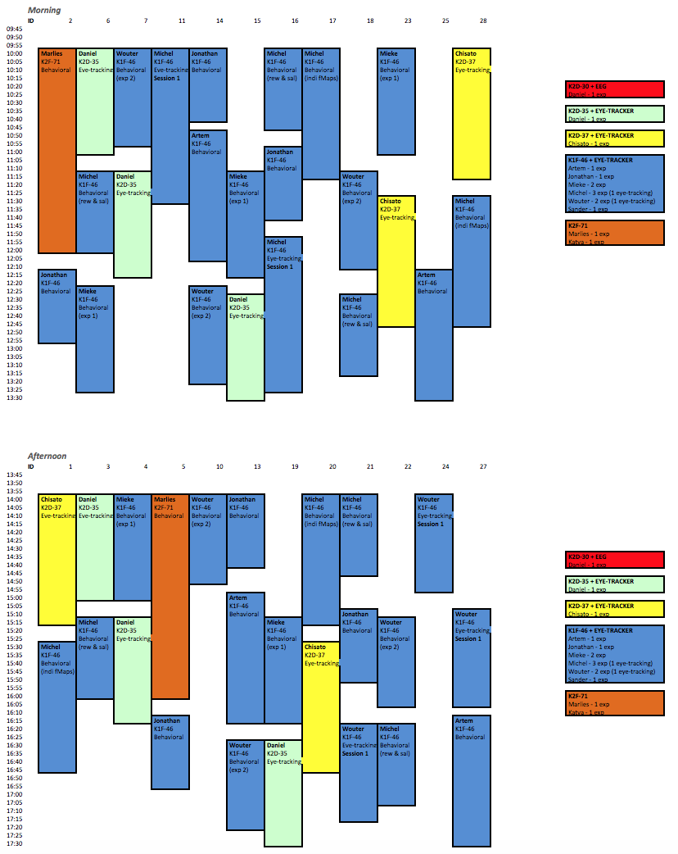

2016
Hints for organizing participant days

- Timing
First, ask PhDs and staff for experiments. Depending on how many experiments are proposed, you can decide how many people you can invite. In order to not waste time, limit the time to one week or so. Make sure they provide enough (better too much than too less) information about requirements regarding equipment, participants, and a rather detailed estimation of running time.
Second, invite participants via the EMS newsletter, Facebook, flyers. Same procedure here, give them a week (usually you’ll be booked out earlier) and ask for enough personal information (see template). Assign an ID to each participant and use it from then one instead of the name, so that you can handle further contact with them, all at once without violating privacy matters. For planning purpose within the department you can of course keep the names (PhDs should know who to test). Make sure not to invite too many people. At some point put (if they are willing to) on the waiting list. Usually some people cancel on short notice, so that you can compensate quickly. The maximum number of people depends on how many experiments are going to be run, how many labs will be used, and the general procedure of the days ( how many experiments per day per subject, how many days per subject, etc). As a guideline keep in mind that we have 13 behavioral cubicles (8 in K1f46, 5 in K2F71), 4-5 eye trackers (35,37,38, soon one in K2F71, one in K1F46), 2 EEG labs. However, some labs are more popular than others, e.g. barely anyone wants to use K2D35. Keep this in mind. In case of emergency you might be able to use some cubicles in K2D30 (social psy), but don’t rely on that

After you collected all experiments and participants prepare the schedule. The best way to do this (in my opinion) is first , trying to get an overview about everything. How many eye tracking studies per lab, same for eeg, and other experiments that require a certain location, preferences of participants: which days are most popular, how many don’t want to do eeg, shock, etc. And this kind of stuff. If you think you have a good overview you can start planning.
You should do this by going from the most restricted ones to those with most freedom. In this sense, you can start with eeg and shock. Hint: Try to assign subjects that can’t to do certain kinds of experiments, to other ‘special’experiments they did not mention (e.g no shock?-->EEG, no EEG?-->eye tracking, and so on) by doing this you make it yourself easier to avoid conflicts in the end. After having finished all the ‘specialties’, try to handle behavioral experiments. First, for all others, and lastly for yourself. Since you will have most experiments of all, you have the most freedom. Therefore, it is recommendable that you use yourself as emergency experiment. If possible leave one room free in your lab, so that you have a buffer, if something goes wrong somewhere. Also, it is good if you assign the exact experiments per subject on short notice (Of course the timeframe should be detailed, but it doenst matter whether subjects to study 1 for 60 mins, or study 2.) . You can decide than which option is best for everyone.
After you finished send it first to the PhDs, fix the issues they found and then send it out to the participants (keeping anonymization in mind). Then fix the issues they find, replace subjects if necessary and be happy if everything works so far (do it know, you won’t have reason for it later).

- During the days

What you do here is pretty much your decision . However, be aware that you’re the one responsible for everything and you’re probably also the one that has the most insight into how things works (I hope at least). Therefore, you’re the first person to go to, in case something is not working out. You can prepare for this in 2 ways:
- Be as flexible as possible. Try to weight the importance of the studies (it is easier to find a replacement for behavior, than for eye tracking). Master your schedule
- Prepare as much as you can before the actual testing starts. E.g. start the experiments in the cubicles, hang out schedules, provide as much information to subjects/phds as possible. Try to seem super strict and not Easy going at all (while staying polite). If you don’t do this, people won’t care for rules.
In the beginning the job will scare you, but you get used to it and then it also will become easier (not easy!).

Good luck
Eduard Ort

